Adding Validation

Main Heading 1
Creating the Presentation Layer 62

Main Heading
The last feature of clsAddress we shall set up is the method Valid. Once that is completed we shall move onto building clsAddressCollection.

Once the middle layer classes are complete we shall attach them to the presentation layer.

So the next stage is to look at the validation method for clsAddress.

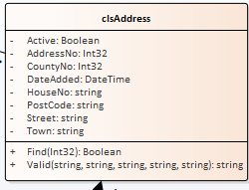

If we examine the validation operation in Enterprise Architect we will see that it consists of several parameters – one for each property…

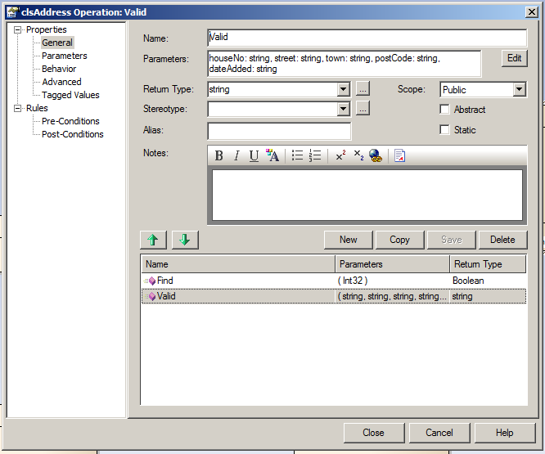

Note also that it has a return data type of string. The idea is that the function will return a concatenated message of what is wrong with the validated data.

There are other design issues to consider at this stage. As a personal preference I like to have my validation code in all one place. This being the case I need to provide a set of test data to satisfy the needs of the multiple parameters in that test method.

You may however prefer to create multiple validation functions, one for each item of test data. Currently this approach is not within the scope of this document.

There isn’t a right answer but if you are taking the latter approach you will need to adapt the examples to suit your design.

(Notice we don’t bother testing the primary key value AddressNo as this will be handled by the data layer! Also the Boolean property Active is currently ignored.)

As in all the above cases we need to make sure that the method actually exists.

The following test does this…

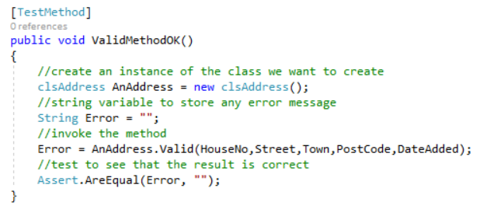
The first big point to note is the question of where are the variables for the Valid method being declared?

Error = AnAddress.Valid(HouseNo,Street,Town,PostCode,DateAdded);

The answer is that we need to define the “good” test data once at the top of the test class giving it class level scope like so...

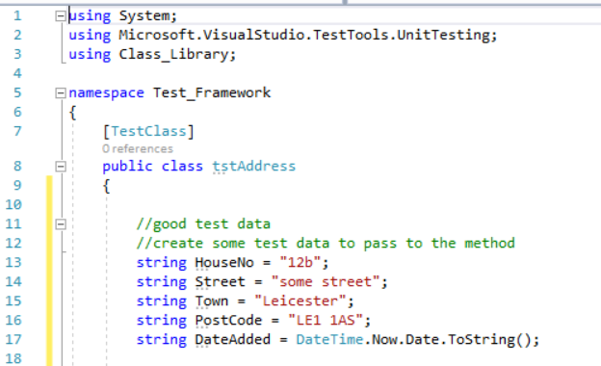

There are two benefits to doing this; firstly having the good test data with class level scope we make it available to all of the tests we are about to create, secondly if at a later date we decide to add a new property to the class then we add the new test data here once. If we don’t make the test data declared once and we have two hundred tests, we are going to have to duplicate the same data two hundred times – too much like hard work for my tastes!

Also note how we are creating variables, one for each parameter. At this stage each variable should contain valid data.

Run the test – watch it fail – fix the test by creating the method. It should still fail!

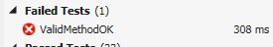

Why?

Take a look at the auto generated code for the Valid method…

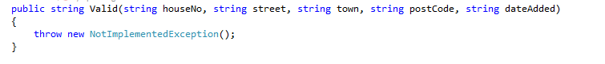

To force this test to pass we need to change the function like so…

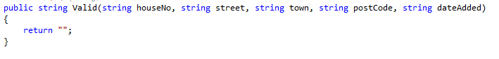
The test should now pass.

The next stage is to create tests for each parameter such that we have a degree of confidence in the code for validation function.

The procedure we shall follow is…

- Decide on a single parameter to test
- Decide on what aspect we are testing – mid, min, max etc.
- Apply the specific test to the parameter whilst providing all of the other parameters with valid data

The first parameter we shall create the unit testing for is HouseNo.

A good place to start is with the test plan format used previously.

Description of Item to Be Tested:

Required Field Y / N

Test Type | Test Data | Expected Result | Actual Result
Extreme Min
Min -1
Min (Boundary)
Min +1
Max -1
Max (Boundary)
Max +1
Mid
Extreme Max
Invalid data type
Other tests

Additional Notes / Instructions:

Using this with the data definition for the table we should be able to construct a series of tests for this parameter.

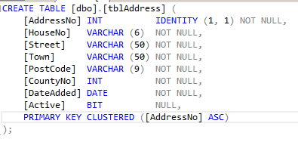

HouseNo is defined in the database as having a maximum field length of 6 characters and may not be null/blank.

This gives us the following test plan…

Description of Item to Be Tested:

HouseNo field which stores the house number of the property. It may contain letters e.g. 15b.

Required Field Y

Test Type | Test Data | Expected Result | Actual Result
Extreme Min | NA
Min -1 | 0 characters | Fail
Min (Boundary) | 1 character | Pass
Min +1 | 2 characters | Pass
Max -1 | 5 characters | Pass
Max (Boundary) | 6 characters | Pass
Max +1 | 7 characters | Fail
Mid | 3 characters | Pass
Extreme Max | 500 characters | Fail
Invalid data type
Other tests

Additional Notes / Instructions:

We are now in a position to create the first test for this parameter…

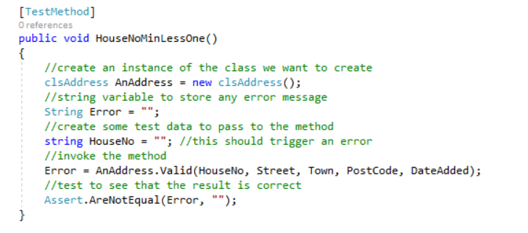

Notice how we are now testing that there IS an error by Assert.IsFalse!

Remember that in testing the HouseNo we need to make sure that all of the other parameters have test data that passes. We know this is the case as we have declared the “good” test data at the top of the class. All we need to do in this and subsequent tests is override the “good” data for a single property with the test data we want to check.

The test should fail…

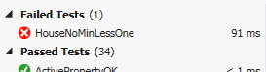

Let’s create some code to trap the error correctly…

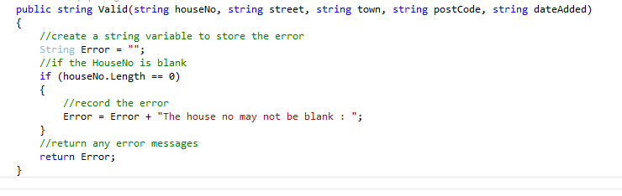

Things to note!
- Notice that the parameter names have automatically had their case set! If you test HouseNo rather than houseNo you will be testing your public property not the parameter!
- Note the concatenation for the error message. The string has been formatted with an extra space at the end! This means that when the next message is concatenated it is a bit easier to read.

The test should now pass.

The following tests should all pass with the validation code as it currently stands.

public void HouseNoMin()
{
//create an instance of the class we want to create
clsAddress AnAddress = new clsAddress();
//string variable to store any error message
String Error = "";
//create some test data to pass to the method
string HouseNo = "a"; //this should be ok
//invoke the method
Error = AnAddress.Valid(HouseNo, Street, Town, PostCode, DateAdded);
//test to see that the result is correct
Assert.AreEqual(Error, "");
}

[TestMethod]
public void HouseNoMinPlusOne()
{
//create an instance of the class we want to create
clsAddress AnAddress = new clsAddress();
//string variable to store any error message
String Error = "";
//create some test data to pass to the method
string HouseNo = "aa"; //this should be ok
//invoke the method
Error = AnAddress.Valid(HouseNo, Street, Town, PostCode, DateAdded);
//test to see that the result is correct
Assert.AreEqual(Error, "");
}

[TestMethod]
public void HouseNoMaxLessOne()
{
//create an instance of the class we want to create
clsAddress AnAddress = new clsAddress();
//string variable to store any error message
String Error = "";
//create some test data to pass to the method
string HouseNo = "aaaaa"; //this should be ok
//invoke the method
Error = AnAddress.Valid(HouseNo, Street, Town, PostCode, DateAdded);
//test to see that the result is correct
Assert.AreEqual(Error, "");
}
[TestMethod]
public void HouseNoMax()
{
//create an instance of the class we want to create
clsAddress AnAddress = new clsAddress();
//string variable to store any error message
String Error = "";
//create some test data to pass to the method
string HouseNo = "aaaaaa"; //this should be ok
//invoke the method
Error = AnAddress.Valid(HouseNo, Street, Town, PostCode, DateAdded);
//test to see that the result is correct
Assert.AreEqual(Error, "");
}

[TestMethod]
public void HouseNoMid()
{
//create an instance of the class we want to create
clsAddress AnAddress = new clsAddress();
//string variable to store any error message
String Error = "";
//create some test data to pass to the method
string HouseNo = "aaa"; //this should be ok
//invoke the method
Error = AnAddress.Valid(HouseNo, Street, Town, PostCode, DateAdded);
//test to see that the result is correct
Assert.AreEqual(Error, "");
}

The last couple of tests are worth paying a little attention to.

Firstly the max + 1 test should fail as the validation code doesn’t address it…

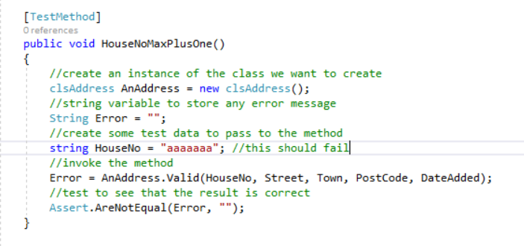

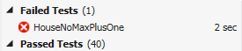

Modifying the validation function like so will deal with the problem…

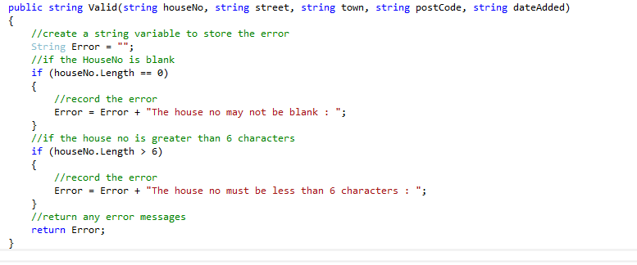

The last test to pay a little attention to is the extreme max test…

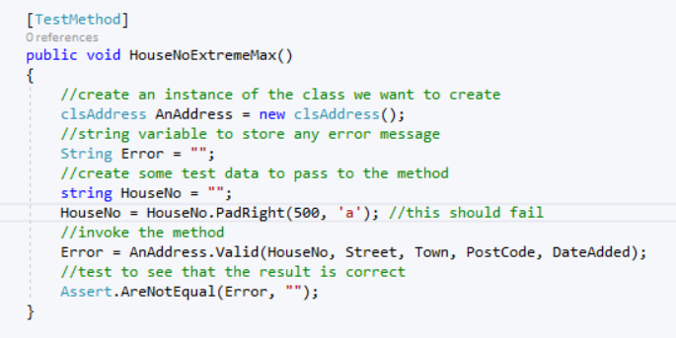

If you get excited about typing 500 characters into a computer then please don’t let me stop you. However it makes far more sense to make use of the PadRight method.

One parameter down - four more to go!

We shall concentrate on the DateAdded parameter next, there are a few useful coding tricks here.

Below is the test plan for the DateAdded parameter.

Description of Item to Be Tested:

DateAdded. This value contains the date on which the record is added to the database. The value may not be less than or greater than today’s date. It must be set to a value and may not be blank.

Required Field Y / N

Test Type | Test Data | Expected Result | Actual Result
Extreme Min | Today’s date less 100 years
Min -1 | Yesterday’s date
Min (Boundary) | Today’s date
Min +1 | Tomorrow’s date
Max -1 | NA (Same as min less 1)
Max (Boundary) | NA (Same as min)
Max +1 | NA (Same as min + 1)
Mid | NA (The date must be today)
Extreme Max | Today’s date plus 100 years
Invalid data type | Any non date data
Other tests | NA

Additional Notes / Instructions:

The issue to consider when creating test data for dates is that the test data will change depending on what day we enter the test data.

We need to design the test methods in such a way that this date sensitivity is taken into account.

Here is the first test - for extreme min…

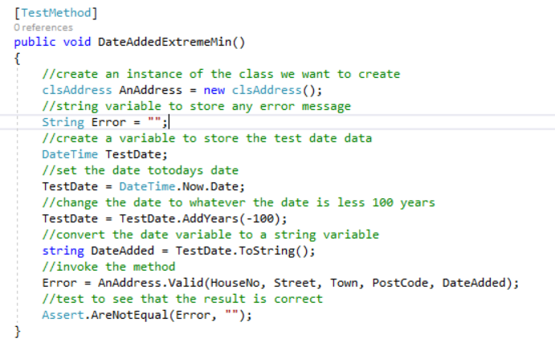

Notice how we are using a variable of data type DateTime to create the test data…

First we declare the variable…

//create a variable to store the test date data
DateTime TestDate;

Next we set it to today’s date….

//set the date totodays date
TestDate = DateTime.Now.Date;

Next we set it to today’s date less 100 years using the AddYears method…

//change the date to whatever the date is less 100 years
TestDate = TestDate.AddYears(-100);

Lastly we copy the test data to our string variable to be passed to the validation function…

//convert the date variable to a string variable
string DateAdded = TestDate.ToString();

The big advantage of using the DateTime data type is that it gives us a whole load of methods for date and time manipulation that the string data type doesn’t give us.

If we run the test it should fail…

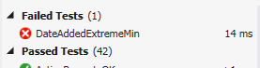

Which means we need to add some code to the validation method like so…

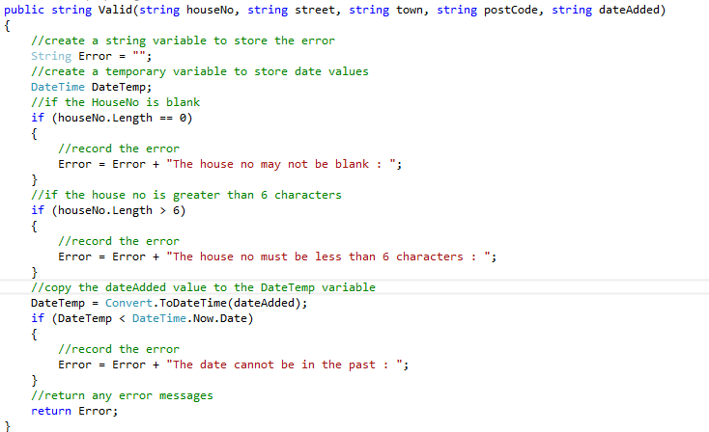

Run the test and it should pass.

Notice in the validation function how we use the variable TempDate.

The reason we have this variable is so that we may take advantage of the DateTime data type’s date/time methods.

e.g….

//check to see if the date is less than today's date
if (DateTemp < DateTime.Now.Date)
{

Here are the all of the boundary tests for DateAdded…

[TestMethod]
public void DateAddedExtremeMin()
{
//create an instance of the class we want to create
clsAddress AnAddress = new clsAddress();
//string variable to store any error message
String Error = "";
//create a variable to store the test date data
DateTime TestDate;
//set the date totodays date
TestDate = DateTime.Now.Date;
//change the date to whatever the date is less 100 years
TestDate = TestDate.AddYears(-100);
//convert the date variable to a string variable
string DateAdded = TestDate.ToString();
//invoke the method
Error = AnAddress.Valid(HouseNo, Street, Town, PostCode, DateAdded);
//test to see that the result is correct
Assert.AreNotEqual(Error, "");
}

[TestMethod]
public void DateAddedMinLessOne()
{
//create an instance of the class we want to create
clsAddress AnAddress = new clsAddress();
//string variable to store any error message
String Error = "";
//create a variable to store the test date data
DateTime TestDate;
//set the date totodays date
TestDate = DateTime.Now.Date;
//change the date to whatever the date is less 1 day
TestDate = TestDate.AddDays(-1);
//convert the date variable to a string variable
string DateAdded = TestDate.ToString();
//invoke the method
Error = AnAddress.Valid(HouseNo, Street, Town, PostCode, DateAdded);
//test to see that the result is correct
Assert.AreNotEqual(Error, "");
}

[TestMethod]
public void DateAddedMin()
{
//create an instance of the class we want to create
clsAddress AnAddress = new clsAddress();
//string variable to store any error message
String Error = "";
//create a variable to store the test date data
DateTime TestDate;
//set the date totodays date
TestDate = DateTime.Now.Date;
//convert the date variable to a string variable
string DateAdded = TestDate.ToString();
//invoke the method
Error = AnAddress.Valid(HouseNo, Street, Town, PostCode, DateAdded);
//test to see that the result is correct
Assert.AreEqual(Error, "");
}
[TestMethod]
public void DateAddedMinPlusOne()
{
//create an instance of the class we want to create
clsAddress AnAddress = new clsAddress();
//string variable to store any error message
String Error = "";
//create a variable to store the test date data
DateTime TestDate;
//set the date totodays date
TestDate = DateTime.Now.Date;
//change the date to whatever the date is plus 1 day
TestDate = TestDate.AddDays(1);
//convert the date variable to a string variable
string DateAdded = TestDate.ToString();
//invoke the method
Error = AnAddress.Valid(HouseNo, Street, Town, PostCode, DateAdded);
//test to see that the result is correct
Assert.AreNotEqual(Error, "");
}

[TestMethod]
public void DateAddedExtremeMax()
{
//create an instance of the class we want to create
clsAddress AnAddress = new clsAddress();
//string variable to store any error message
String Error = "";
//create a variable to store the test date data
DateTime TestDate;
//set the date totodays date
TestDate = DateTime.Now.Date;
//change the date to whatever the date is plus 100 years
TestDate = TestDate.AddYears(100);
//convert the date variable to a string variable
string DateAdded = TestDate.ToString();
//invoke the method
Error = AnAddress.Valid(HouseNo, Street, Town, PostCode, DateAdded);
//test to see that the result is correct
Assert.AreNotEqual(Error, "");
}
Here is the validation code to deal with these tests…

public string Valid(string houseNo, string street, string town, string postCode, string dateAdded)
{
//create a string variable to store the error
String Error = "";
//create a temporary variable to store date values
DateTime DateTemp;
//if the HouseNo is blank
if (houseNo.Length == 0)
{
//record the error
Error = Error + "The house no may not be blank : ";
}
//if the house no is greater than 6 characters
if (houseNo.Length > 6)
{
//record the error
Error = Error + "The house no must be less than 6 characters : ";
}
//copy the dateAdded value to the DateTemp variable
DateTemp = Convert.ToDateTime(dateAdded);
if (DateTemp < DateTime.Now.Date)
{
//record the error
Error = Error + "The date cannot be in the past : ";
}
//check to see if the date is greater than today's date
if (DateTemp > DateTime.Now.Date)
{
//record the error
Error = Error + "The date cannot be in the future : ";
}
//return any error messages
return Error;
}
The final test we will look at is the test for invalid data…

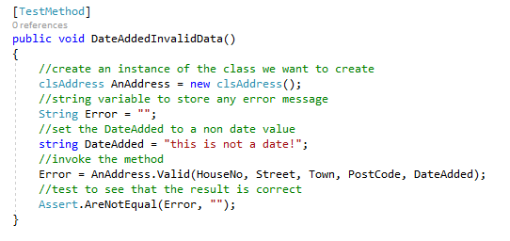

As usual the test should fail…

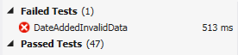

To solve this problem we will use the debugger.

Press F9 to generate a break point like so…

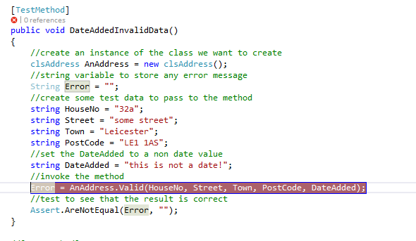

Now right click on the test and select debug tests…

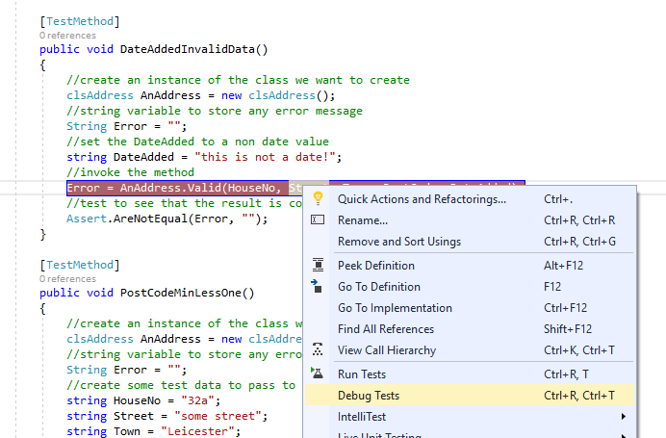

Visual Studio should then stop at the break point with yellow highlighting…

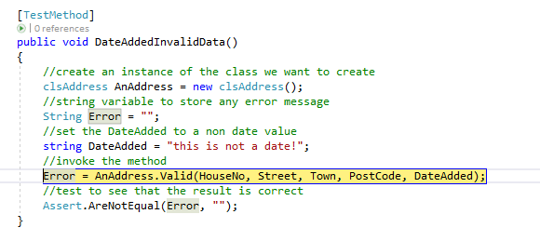

Press F11 to step into the code for the validation method.

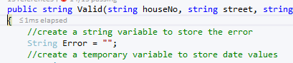

Now press F10 to step line by line through the function.

When the following line is highlighted, stop and inspect the data value about to be assigned…

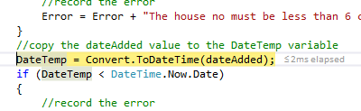

The string variable DateAdded contains the text data “this is not a date!”.

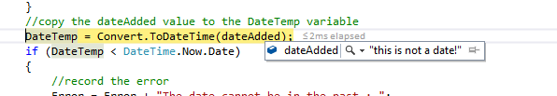

The assignment operation is about to convert that data to a date value and assign it to the variable DateTemp.

Here is where the problem lies.

Press F10 one more time and watch the program crash…

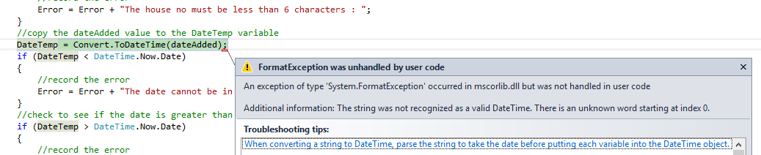

Stop the program running and let’s add the code to fix the problem.

The issue is that we need to test the data stored in DateAdded prior to trying to assign it to the variable DateTemp.

If the data is a valid date then go ahead with the assignment and proceed to the remaining date validation.

If the data is not a valid date then stop working with the data as if it is a date and flag an error.

The following code will do this for us…

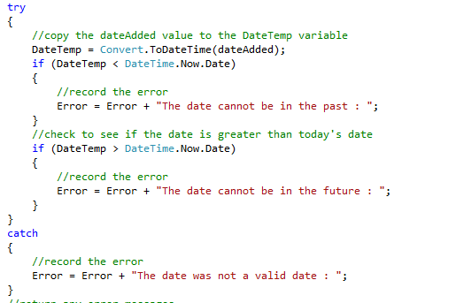

Two parameters down three to go!

Here are the test plans for the remaining three parameters with their test methods…

Description of Item to Be Tested:

PostCode: Required field max length 9 characters. (We will ignore the complexities of post code formatting for the moment!)

Required Field Y

Test Type | Test Data | Expected Result | Actual Result
Extreme Min | NA
Min -1 | Blank | Error
Min (Boundary) | 1 character | OK
Min +1 | 2 characters | OK
Max -1 | 8 characters | OK
Max (Boundary) | 9 characters | OK
Max +1 | 10 characters | Error
Mid | 4 characters | OK
Extreme Max | 500 characters | Error
Invalid data type | We shall ignore this for the moment but post codes do have a format we may need to look at.
Other tests

Additional Notes / Instructions:

[TestMethod]
public void PostCodeMinLessOne()
{
//create an instance of the class we want to create
clsAddress AnAddress = new clsAddress();
//string variable to store any error message
String Error = "";
//this should fail
string PostCode = "";
//invoke the method
Error = AnAddress.Valid(HouseNo, Street, Town, PostCode, DateAdded);
//test to see that the result is correct
Assert.AreNotEqual(Error, "");
}

[TestMethod]
public void PostCodeMin()
{
//create an instance of the class we want to create
clsAddress AnAddress = new clsAddress();
//string variable to store any error message
String Error = "";
//this should pass
string PostCode = "a";
//invoke the method
Error = AnAddress.Valid(HouseNo, Street, Town, PostCode, DateAdded);
//test to see that the result is correct
Assert.AreEqual(Error, "");
}

[TestMethod]
public void PostCodeMinPlusOne()
{
//create an instance of the class we want to create
clsAddress AnAddress = new clsAddress();
//string variable to store any error message
String Error = "";
//this should pass
string PostCode = "aa";
//invoke the method
Error = AnAddress.Valid(HouseNo, Street, Town, PostCode, DateAdded);
//test to see that the result is correct
Assert.AreEqual(Error, "");
}

[TestMethod]
public void PostCodeMaxLessOne()
{
//create an instance of the class we want to create
clsAddress AnAddress = new clsAddress();
//string variable to store any error message
String Error = "";
//this should pass
string PostCode = "aaaaaaaa";
//invoke the method
Error = AnAddress.Valid(HouseNo, Street, Town, PostCode, DateAdded);
//test to see that the result is correct
Assert.AreEqual(Error, "");
}

[TestMethod]
public void PostCodeMax()
{
//create an instance of the class we want to create
clsAddress AnAddress = new clsAddress();
//string variable to store any error message
String Error = "";
//this should pass
string PostCode = "aaaaaaaaa";
//invoke the method
Error = AnAddress.Valid(HouseNo, Street, Town, PostCode, DateAdded);
//test to see that the result is correct
Assert.AreEqual(Error, "");
}

[TestMethod]
public void PostCodeMaxPlusOne()
{
//create an instance of the class we want to create
clsAddress AnAddress = new clsAddress();
//string variable to store any error message
String Error = "";
//this should fail
string PostCode = "aaaaaaaaaa";
//invoke the method
Error = AnAddress.Valid(HouseNo, Street, Town, PostCode, DateAdded);
//test to see that the result is correct
Assert.AreNotEqual(Error, "");
}

[TestMethod]
public void PostCodeMid()
{
//create an instance of the class we want to create
clsAddress AnAddress = new clsAddress();
//string variable to store any error message
String Error = "";
//this should pass
string PostCode = "aaaa";
//invoke the method
Error = AnAddress.Valid(HouseNo, Street, Town, PostCode, DateAdded);
//test to see that the result is correct
Assert.AreEqual(Error, "");
}
Description of Item to Be Tested:

Street : May not be blank max length 50 characters

Required Field Y

Test Type | Test Data | Expected Result | Actual Result
Extreme Min | NA
Min -1 | Blank | Error
Min (Boundary) | 1 character | OK
Min +1 | 2 characters | OK
Max -1 | 49 characters | OK
Max (Boundary) | 50 characters | OK
Max +1 | 51 characters | Error
Mid | 25 characters | OK
Extreme Max | 500 characters | Error
Invalid data type | NA
Other tests | NA

Additional Notes / Instructions:

[TestMethod]
public void StreetMinLessOne()
{
//create an instance of the class we want to create
clsAddress AnAddress = new clsAddress();
//string variable to store any error message
String Error = "";
//this should fail
string Street = "";
//invoke the method
Error = AnAddress.Valid(HouseNo, Street, Town, PostCode, DateAdded);
//test to see that the result is correct
Assert.AreNotEqual(Error, "");
}

[TestMethod]
public void StreetMin()
{
//create an instance of the class we want to create
clsAddress AnAddress = new clsAddress();
//string variable to store any error message
String Error = "";
//this should pass
string Street = "a";
//invoke the method
Error = AnAddress.Valid(HouseNo, Street, Town, PostCode, DateAdded);
//test to see that the result is correct
Assert.AreEqual(Error, "");
}

[TestMethod]
public void StreetMinPlusOne()
{
//create an instance of the class we want to create
clsAddress AnAddress = new clsAddress();
//string variable to store any error message
String Error = "";
//this should pass
string Street = "aa";
//invoke the method
Error = AnAddress.Valid(HouseNo, Street, Town, PostCode, DateAdded);
//test to see that the result is correct
Assert.AreEqual(Error, "");
}

[TestMethod]
public void StreetMaxLessOne()
{
//create an instance of the class we want to create
clsAddress AnAddress = new clsAddress();
//string variable to store any error message
String Error = "";
//this should pass
string Street = "";
Street = Street.PadRight(49, 'a');
//invoke the method
Error = AnAddress.Valid(HouseNo, Street, Town, PostCode, DateAdded);
//test to see that the result is correct
Assert.AreEqual(Error, "");
}

[TestMethod]
public void StreetMax()
{
//create an instance of the class we want to create
clsAddress AnAddress = new clsAddress();
//string variable to store any error message
String Error = "";
//this should pass
string Street = "";
Street = Street.PadRight(50, 'a');
//invoke the method
Error = AnAddress.Valid(HouseNo, Street, Town, PostCode, DateAdded);
//test to see that the result is correct
Assert.AreEqual(Error, "");
}

[TestMethod]
public void StreetMaxPlusOne()
{
//create an instance of the class we want to create
clsAddress AnAddress = new clsAddress();
//string variable to store any error message
String Error = "";
//this should fail
string Street = "";
//invoke the method
Error = AnAddress.Valid(HouseNo, Street, Town, PostCode, DateAdded);
//test to see that the result is correct
Assert.AreNotEqual(Error, "");
}

[TestMethod]
public void StreetMid()
{
//create an instance of the class we want to create
clsAddress AnAddress = new clsAddress();
//string variable to store any error message
String Error = "";
//this should pass
string Street = "";
Street = Street.PadRight(25, 'a');
//invoke the method
Error = AnAddress.Valid(HouseNo, Street, Town, PostCode, DateAdded);
//test to see that the result is correct
Assert.AreEqual(Error, "");
}
Description of Item to Be Tested:

Town : required field max length 50 characters

Required Field Y

Test Type | Test Data | Expected Result | Actual Result
Extreme Min | NA
Min -1 | Blank | Error
Min (Boundary) | 1 character | OK
Min +1 | 2 characters | OK
Max -1 | 49 characters | OK
Max (Boundary) | 50 characters | OK
Max +1 | 51 characters | Error
Mid | 25 characters | OK
Extreme Max | 500 characters | Error
Invalid data type | NA
Other tests | NA

Additional Notes / Instructions:

[TestMethod]
public void TownMinLessOne()
{
//create an instance of the class we want to create
clsAddress AnAddress = new clsAddress();
//string variable to store any error message
String Error = "";
//this should fail
string Town = "";
//invoke the method
Error = AnAddress.Valid(HouseNo, Street, Town, PostCode, DateAdded);
//test to see that the result is correct
Assert.AreNotEqual(Error, "");
}

[TestMethod]
public void TownMin()
{
//create an instance of the class we want to create
clsAddress AnAddress = new clsAddress();
//string variable to store any error message
String Error = "";
//this should pass
string Town = "a";
//invoke the method
Error = AnAddress.Valid(HouseNo, Street, Town, PostCode, DateAdded);
//test to see that the result is correct
Assert.AreEqual(Error, "");
}

[TestMethod]
public void TownMinPlusOne()
{
//create an instance of the class we want to create
clsAddress AnAddress = new clsAddress();
//string variable to store any error message
String Error = "";
//this should pass
string Town = "aa";
//invoke the method
Error = AnAddress.Valid(HouseNo, Street, Town, PostCode, DateAdded);
//test to see that the result is correct
Assert.AreEqual(Error, "");
}

[TestMethod]
public void TownMaxLessOne()
{
//create an instance of the class we want to create
clsAddress AnAddress = new clsAddress();
//string variable to store any error message
String Error = "";
//this should pass
string Town = "";
Town = Town.PadRight(49, 'a');
//invoke the method
Error = AnAddress.Valid(HouseNo, Street, Town, PostCode, DateAdded);
//test to see that the result is correct
Assert.AreEqual(Error, "");
}

[TestMethod]
public void TownMax()
{
//create an instance of the class we want to create
clsAddress AnAddress = new clsAddress();
//string variable to store any error message
String Error = "";
//this should pass
string Town = "";
Town = Town.PadRight(50, 'a');
//invoke the method
Error = AnAddress.Valid(HouseNo, Street, Town, PostCode, DateAdded);
//test to see that the result is correct
Assert.AreEqual(Error, "");
}

[TestMethod]
public void TownMaxPlusOne()
{
//create an instance of the class we want to create
clsAddress AnAddress = new clsAddress();
//string variable to store any error message
String Error = "";
//this shold fail
string Town = "";
Town = Town.PadRight(51, 'a');
//invoke the method
Error = AnAddress.Valid(HouseNo, Street, Town, PostCode, DateAdded);
//test to see that the result is correct
Assert.AreNotEqual(Error, "");
}

[TestMethod]
public void TownMid()
{
//create an instance of the class we want to create
clsAddress AnAddress = new clsAddress();
//string variable to store any error message
String Error = "";
//this should pass
string Town = "";
Town = Town.PadRight(25, 'a');
//invoke the method
Error = AnAddress.Valid(HouseNo, Street, Town, PostCode, DateAdded);
//test to see that the result is correct
Assert.AreEqual(Error, "");
}

Here is the code for the validation method…

public string Valid(string houseNo, string street, string town, string postCode, string dateAdded)
{
//create a string variable to store the error
String Error = "";
//create a temporary variable to store date values
DateTime DateTemp;
//if the HouseNo is blank
if (houseNo.Length == 0)
{
//record the error
Error = Error + "The house no may not be blank : ";
}
//if the house no is greater than 6 characters
if (houseNo.Length > 6)
{
//record the error
Error = Error + "The house no must be less than 6 characters : ";
}
try
{
//copy the dateAdded value to the DateTemp variable
DateTemp = Convert.ToDateTime(dateAdded);
if (DateTemp < DateTime.Now.Date)
{
//record the error
Error = Error + "The date cannot be in the past : ";
}
//check to see if the date is greater than today's date
if (DateTemp > DateTime.Now.Date)
{
//record the error
Error = Error + "The date cannot be in the future : ";
}
}
catch
{
//record the error
Error = Error + "The date was not a valid date : ";
}
//is the post code blank
if (postCode.Length == 0)
{
//record the error
Error = Error + "The post code may not be blank : ";
}
//if the post code is too long
if (postCode.Length > 9)
{
//record the error
Error = Error + "The post code must be less than 9 characters : ";
}
//is the street blank
if (street.Length == 0)
{
//record the error
Error = Error + "The street may not be blank : ";
}
//if the street is too long
if (street.Length > 50)
{
//record the error
Error = Error + "The street must be less than 50 characters : ";
}
//is the town blank
if (town.Length == 0)
{
//record the error
Error = Error + "The town may not be blank : ";
}
//if the town is too long
if (town.Length > 50)
{
//record the error
Error = Error + "The town must be less than 50 characters : ";
}
//return any error messages
return Error;
}

Creating the Presentation Layer

